**Assignment 1: 2D Kinematics**

**Part 1:**

Position Vectors:

Trunk Vector: [-50, -131.80], Thigh Vector: [-141, -390.09], Shank Vector: [-269.84, -254.9]

Segment Angles:

Trunk Angle: 69.23 degrees, Thigh Angle: 70.13 degrees, Shank Angle: 43.37 degrees

Joint Angles:

Hip Angle: -0.90 degrees, Knee Angle: 26.76 degrees

**Part 2:**

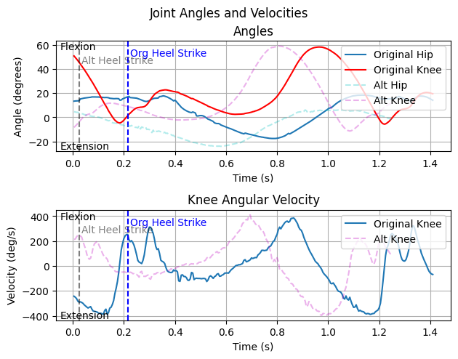

Figure 1: Plots of the hip and knee angle, and angular velocities of the knee. Solid timeseries indicate original data, and dotted timeseries indicate alternate data.

The knee and hip timeseries show the stance phase of the gait cycle. In the original data (solid lines), the knee extends, then slightly flexes right before initial heel strike, after which the knee continues to flex as it accepts increased GRF. The knee then begins to extend as the individual propels their CoM forward, after which the knee flexes as the toe off occurs, and the individual enters the swing phase of the gait cycle. The angular velocity of the knee reflects this, as there is a sharp increase in negative angular velocity as the knee extends prior to heelstrike. There is also a positive angular velocity going into and after heel strike, showing the flexion of the knee, after which a gradual increase in positive angular velocity occurs as the knee flexes. Regarding the hip, it is flexed through heel strike, as the leg is in front of the CoM, it then extends after heel strike as the individual propels their CoM forward and begins to flex during the swing phase.

The movement patterns of the original and “Alt” files are very similar, with only very slight differences. The original knee exhibits ~5 degrees more knee flexion after initial heel strike, showing a slightly less stiff knee. However, alternate data sample is similarly more extended prior to heel strike, meaning the maker placement could have had an effect on these joint angles, as the alternate knee shows ~5 degrees of hyperextension, meaning the increased flexion seen in the original data could simply be due to differences in marker placement. The alternate data also exhibits more hip extension, which is supported by the increase in knee extension. This increased hip extension could be due to the individual needing to extend the hip more in order to propel themselves forward with a more extended knee, but could also be due to the previously mentioned differing marker placement. The angular velocity profiles are also very similar, with the only differences of note being slightly higher positive angular velocities immediately following heel strike in the original data compared to the alternate. This could be due to the original individual heel striking with a more flexed and less stiff knee, leading to more knee cave and higher angular velocities.

**GenAI Appendix:**

Prompt: how can I find local peaks in timeseries data in python?

Output: To find **local peaks** in time series data using Python, the most powerful and flexible tool is scipy.signal.find_peaks. It lets you detect peaks based on height, prominence, distance, and more.

